***NAME : Himanshu Dixit***

***ENROLL NO. : B64178***

***BATCH : B10***

***Software Development Fundamentals – I(15B11CI111)***

***ODD 2021***

***Tutorial Sheet – 10***

***Q1.*** *Use pointer to delete all occurrences of a given character in the string. The program should output the corrected string with no holes.*

***Solution:***

#include<stdio.h>

int main()

{

char *s,str[50],a;

printf("Enter a string : ");

gets(str);

s=str;

printf("Enter a character you wants to remove form the string : ");

scanf("%c",&a);

printf("string is : ");

while(*s != '\0')

{

if(*s != a)

{

printf("%c",*s);

}

s++;

}

return 0;

}

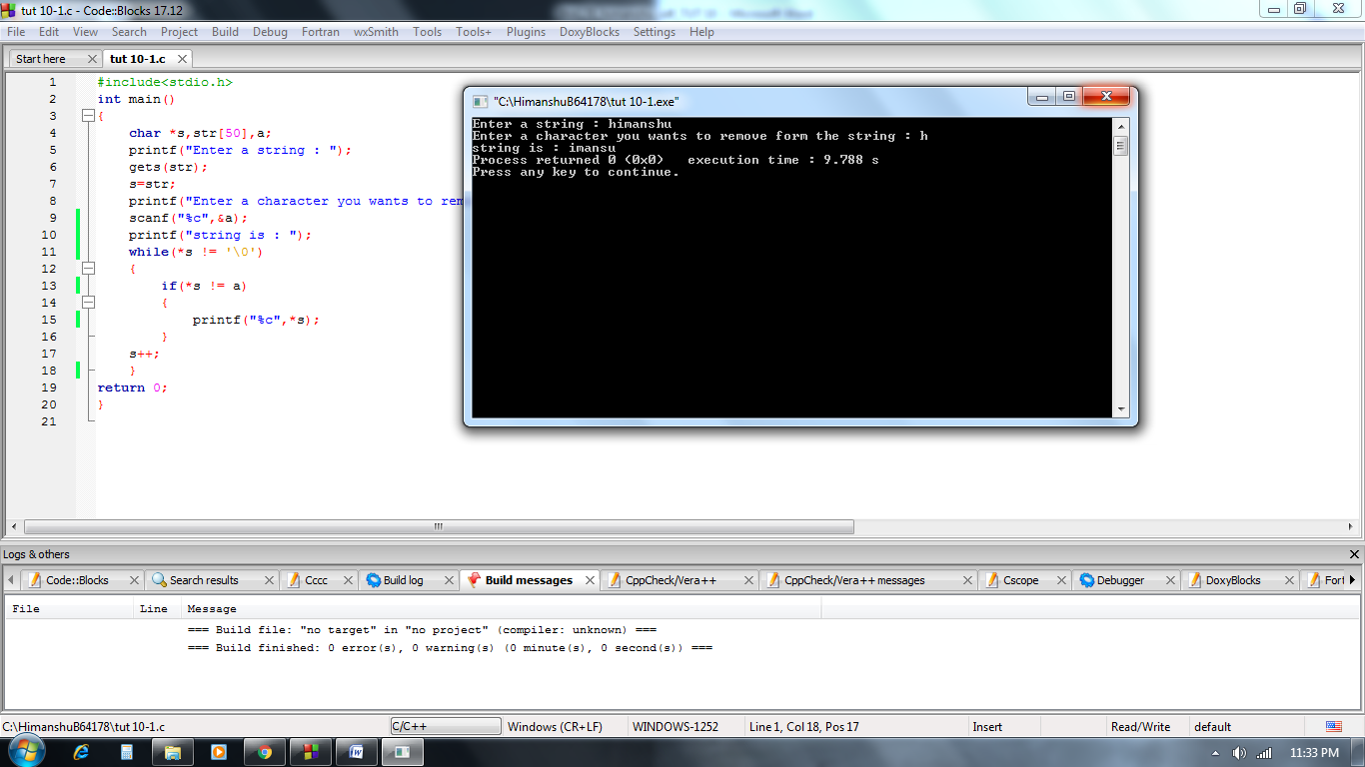

***Q2.*** *Write a program to compute the LCM of ’n’ user input numbers.*

***Solution:***

#include<stdio.h>

int hcf(int a,int b)

{

int k=b;

while(k>1)

{

if(a%k==0 && b%k==0)

return k;

k--;

}

return k;

}

int main()

{

int *a,n,b[100],lcm;

printf("Total number : ");

scanf("%d",&n);

for(int i=0;i<n;i++)

{

scanf("%d",&b[i]);

}

a=b;

lcm=b[0];

for(int i=1;i<n;i++)

{

int gcd=hcf(*(a+i),lcm);

lcm=(lcm * (*(a+i)))/gcd;

}

printf("LCM is %d",lcm);

return 0;

}

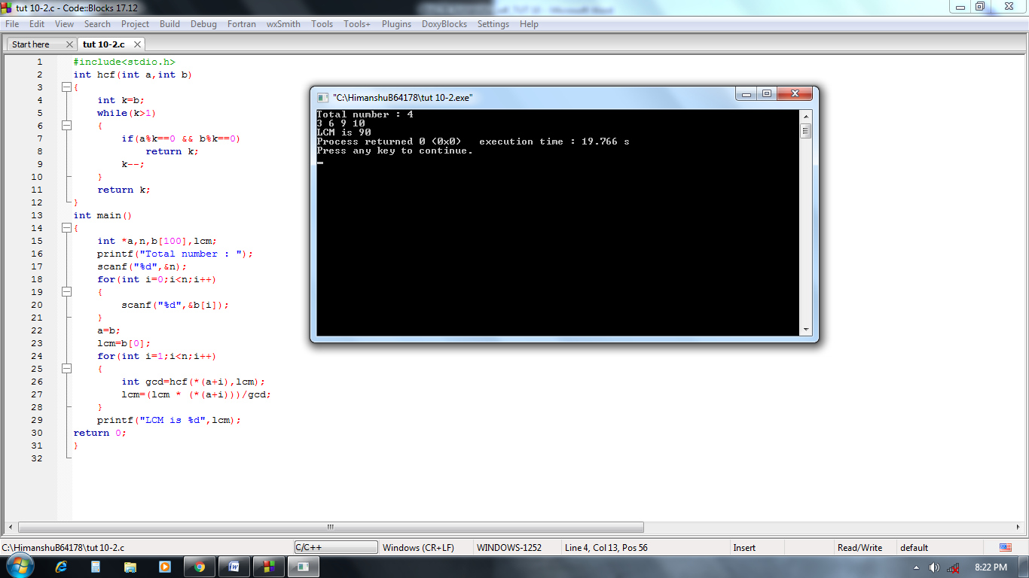

***Q3.*** *What will be the output of the program?*

***a)*** *int main()*

*{*

*int i=3, *j, k;*

*j = &i;*

*printf("%d\n", i**j*i+*j);*

*return 0;*

*}*

***Solution:***

30

***b)*** *int main()*

*{*

*int x=30, *y, *z;*

*y=&x; /* Assume address of x is 500 and integer is 4 byte size */*

*z=y;*

*\*y++=*z++;*

*x++;*

*printf("x=%d, y=%d, z=%d\n", x, y, z);*

*return 0;*

*}*

***Solution:***

x=31

y=504

z=504

***c)*** *int main()*

*{*

*char str[20] = "Hello";*

*char *const p=str;*

*\*p='M';*

*printf("%s\n", str);*

*return 0;*

*}*

***Solution:***

Mello

***d)*** *int main()*

*{*

*int ***r, **q, *p, i=8;*

*p = &i;*

*q = &p;*

*r = &q;*

*printf("%d, %d, %d\n", *p, **q, ***r);*

*return 0;*

*}*

***Solution:***

8, 8, 8

***e)*** *int main()*

*{*

*char *str;*

*str = "%s";*

*printf(str, "K\n");*

*return 0;*

*}*

***Solution:***

K

***f)*** *int main()*

*{*

*printf("%d, %d\n", sizeof(NULL), sizeof(""));*

*return 0;*

*}*

***Solution:***

4, 1

***g)*** *int main()*

*{*

*void *vp;*

*char ch=74, *cp="JACK";*

*int j=65;*

*vp=&ch;*

*printf("%c", *(char*)vp);*

*vp=&j;*

*printf("%c", *(int*)vp);*

*vp=cp;*

*printf("%s", (char*)vp+2);*

*return 0;*

*}*

***Solution:***

JACK

***h)*** *int main()*

*{*

*int arr[2][2][2] = {10, 2, 3, 4, 5, 6, 7, 8};*

*int *p, *q;*

*p = &arr[1][1][1];*

*q = (int*) arr;*

*printf("%d, %d\n", *p, *q);*

*return 0;*

*}*

***Solution:***

8, 10

***i)*** *int main()*

*{*

*int a[3][4] = { 1, 2, 3, 4, 5, 6, 7, 8, 9, 10, 11, 12 };*

*printf("%u, %u, %u\n", a[0]+1, *(a[0]+1), *(*(a+0)+1));*

*return 0;*

*}*

*array begins at the location 1002*

***Solution:***

1006 2 2

***j)*** *int main()*

*{*

*int arr[3] = {2, 3, 4};*

*char *p;*

*p = arr;*

*p = (char*)((int*)(p));*

*printf("%d, ", *p);*

*p = (int*)(p+1);*

*printf("%d", *p);*

*return 0;*

*}*

***Solution:***

2, 3

***k)*** *int main()*

*{*

*char *str;*

*str = "%d\n";*

*str++;*

*str++;*

*printf(str-2, 300);*

*return 0;*

*}*

***Solution:***

300

***l)*** *int main()*

*{*

*char str[] = "peace";*

*char *s = str;*

*printf("%s\n", s++ +3);*

*return 0;*

*}*

***Solution:***

ce

***m)*** *int main()*

*{*

*char *p;*

*p="hello";*

*printf("%s\n", *&*&p);*

*return 0;*

*}*

***Solution:***

hello

***n)*** *int main()*

*{*

*char *p;*

*p="hello";*

*printf("%s\n", *&*&p);*

*return 0;*

*}*

*the array begins at location 1002*

***Solution:***

hello

***o)*** *int main()*

*{*

*char str1[] = "India";*

*char str2[] = "BIX";*

*char *s1 = str1, *s2=str2;*

*while(*s1++ = *s2++)*

*printf("%s", str1);*

*printf("\n");*

*return 0;*

*}*

***Solution:***

BndiaBIdiaBIXia

***p)*** *#include<stdio.h>*

*#include<string.h>*

*int main()*

*{*

*int i, n;*

*char *x="Alice";*

*n = strlen(x);*

*for(i=0; i<=n; i++)*

*{*

*printf("%s ", x);*

*x++;*

*}*

*printf("\n", x);*

*return 0;*

*}*

***Solution:***

Alice lice ice ce e